**Worksheet 1.1**

**Student Name:** Vivek Kumar **UID:** 21BCS8129

**Branch:** BE-CSE (LEET) **Section/Group:** 20BCS-808/B

**Semester:** 4th Sem **Date of Performance:** 20/02/2022

**Subject Name:** MPI Lab **Subject Code:** 22E-20CSP-253

**1. Aim/Overview of the practical:**

Addition of two 8bit numbers, sum 8 bits.

**2. Task to be done:**

Write the 8085 Micro Processor program to calculate the addition of two 8bit numbers.

**3. Apparatus/Simulator used (For applied/experimental sciences/materials-based labs):**

1. 8085 Jubin simulator version 2 (Microprocessor Simulator)
2. Java (jdk/ jre1.8.0_321)

**4. Algorithm/Flowchart (For programming-based labs):**

1. Load the first number from memory location 1050 to Memory.
2. Move the content of memory to accumulator,
3. Move the content of accumulator to register H.
4. Load the second number from memory location 1051 to Memory.
5. Then add the content of register H and accumulator using “ADD” instruction and storing result at accumulator.
6. Store the addition of both number in the register location at 1052.

**5. Description/ Code:**

**According to the Given Instruction In Manual**

# ORG 1000H

LXI H,1000

MOV A,M

INX H

MOV B,M

MVI C,00

ADD B

JNC 000D

INR C

000D: INX H

MOV M,C

HLT

# ORG 1000H

# DB 11H, 20H

**By Doing Experiment:**

# ORG 1000H

LXI H,1050

MOV A,M

INX H

ADD M

INX H

MOV M,A

HLT

# ORG 1050H

# DB 11H, 29H

**6. Result/Output/Writing Summary:**

**According to the Given Instruction In Manual:**

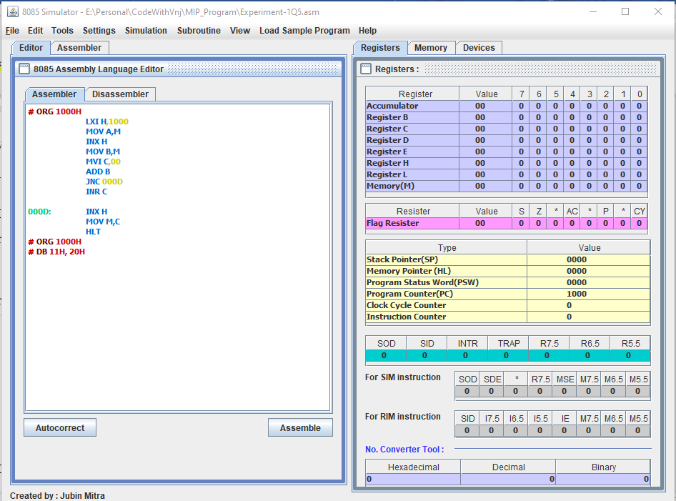

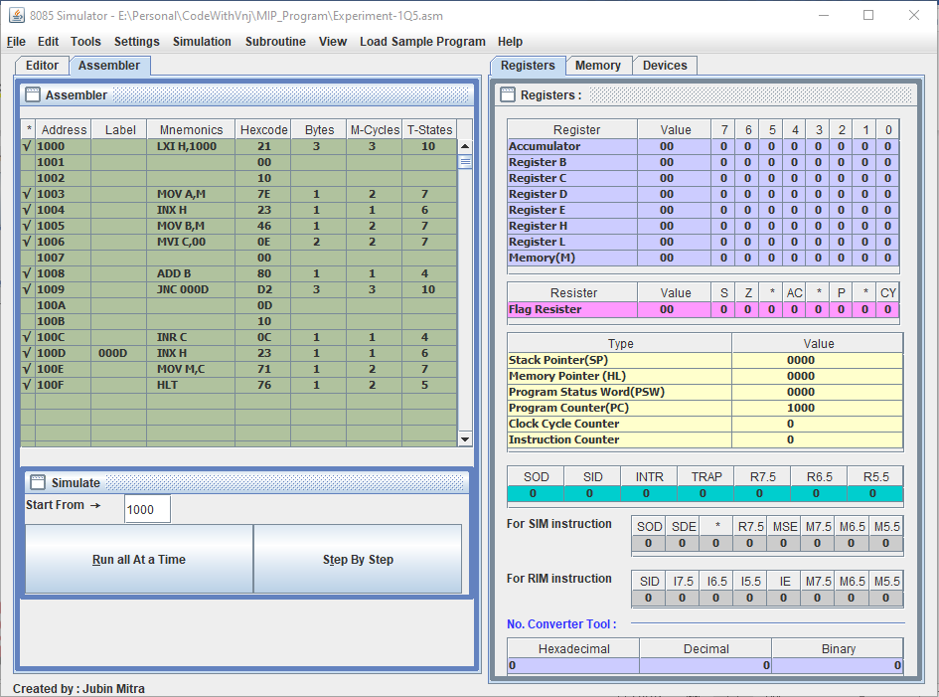

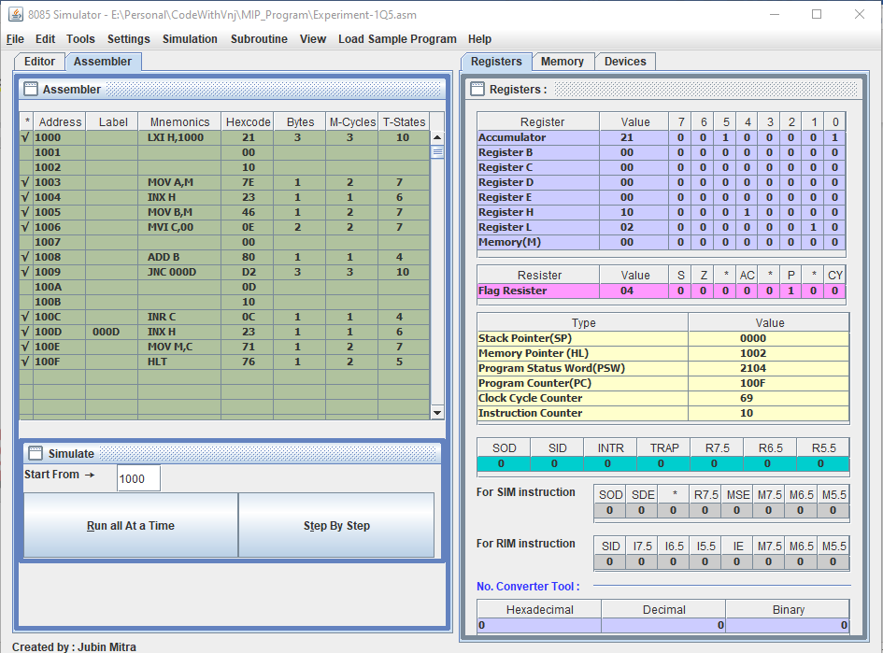

**By Doing Experiment Step By Step:**

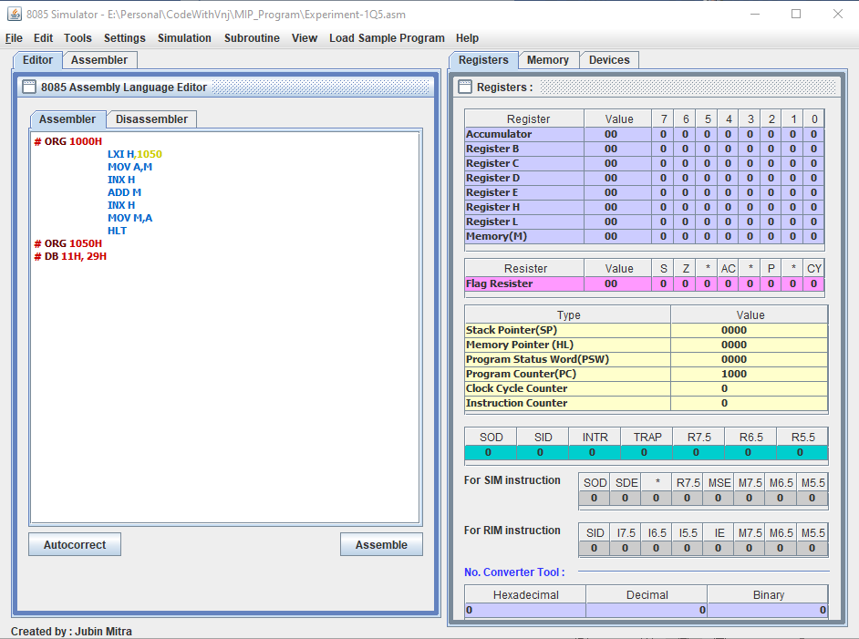

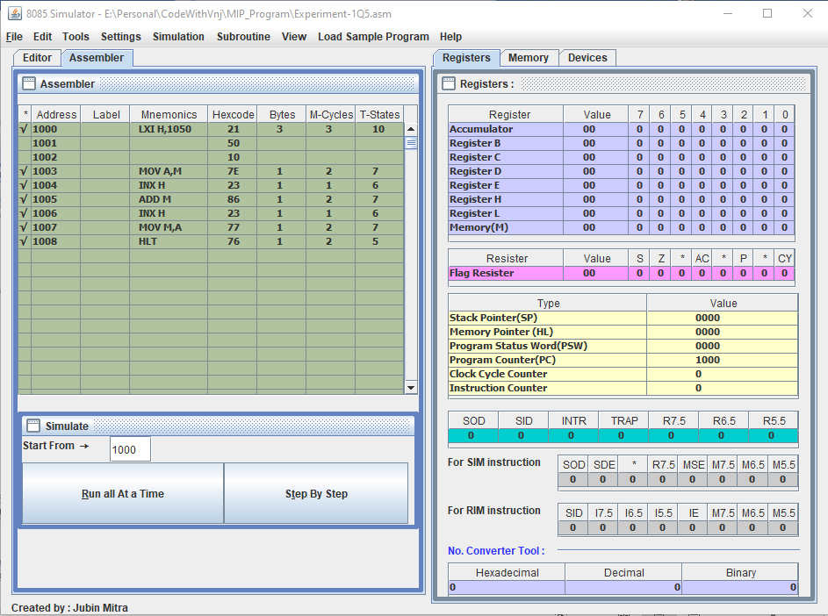

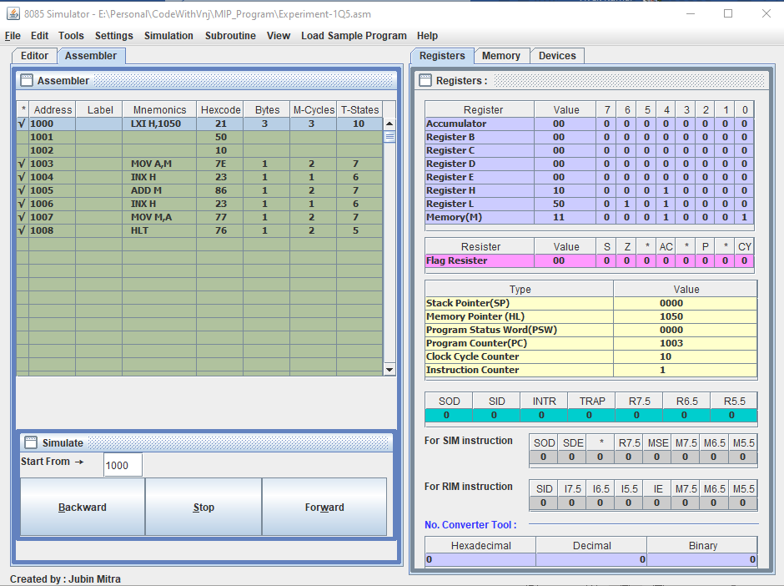

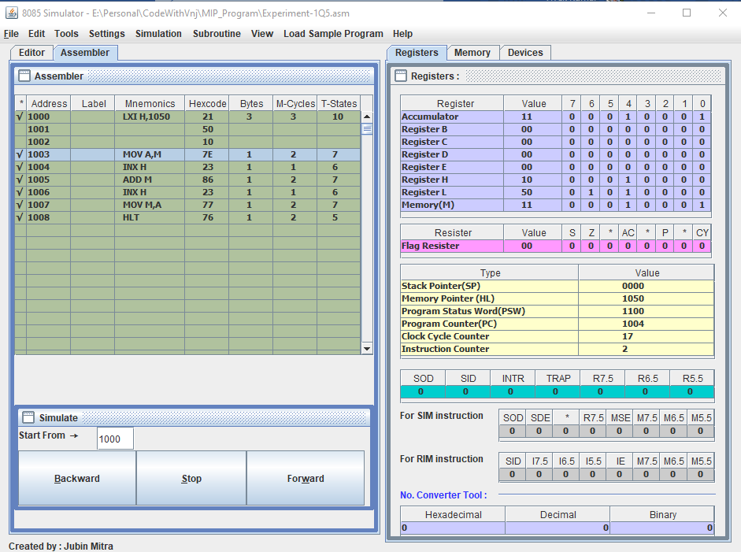

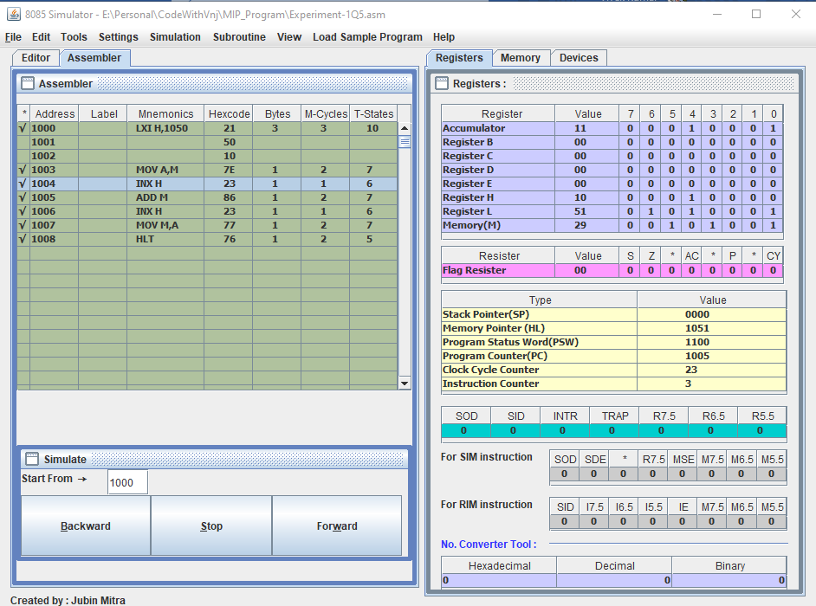

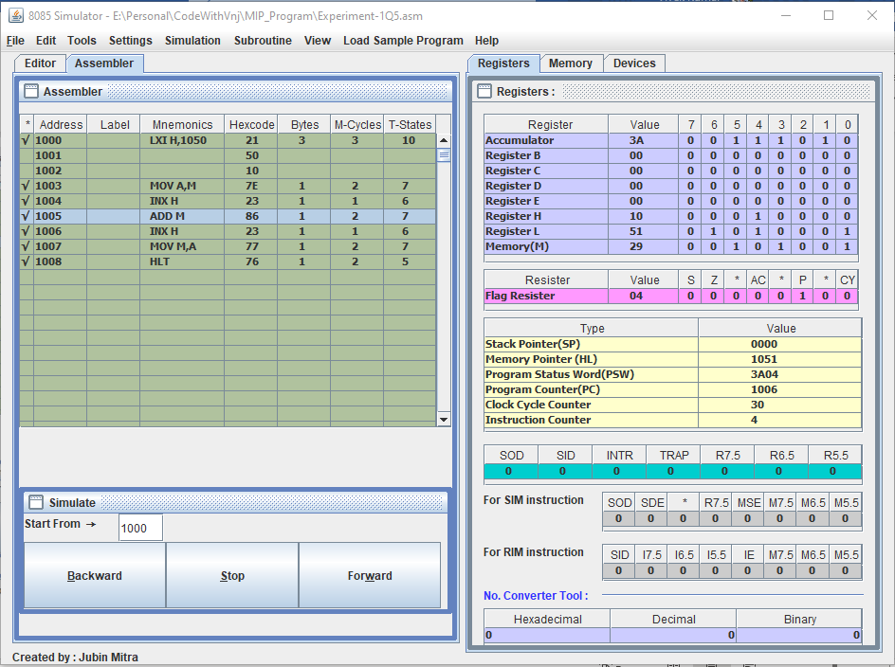

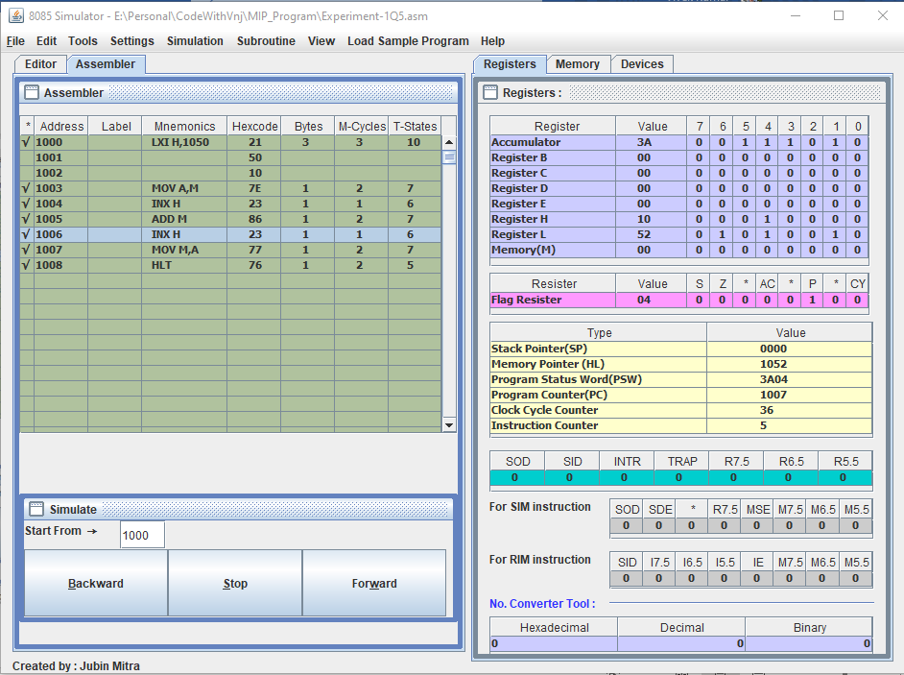

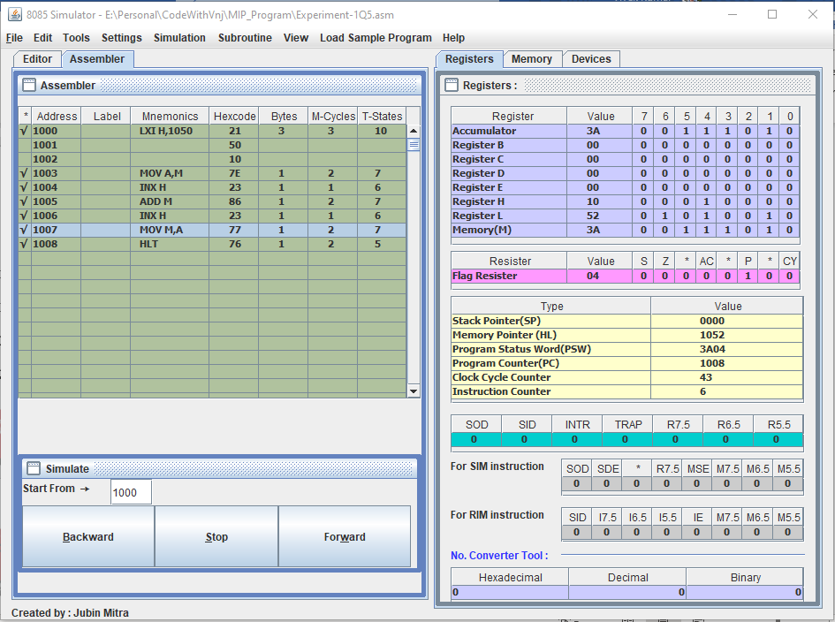

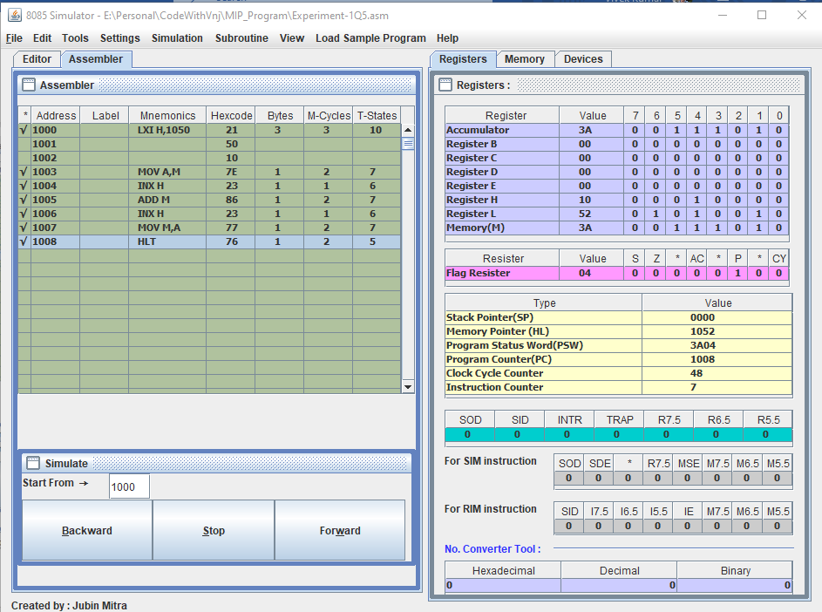

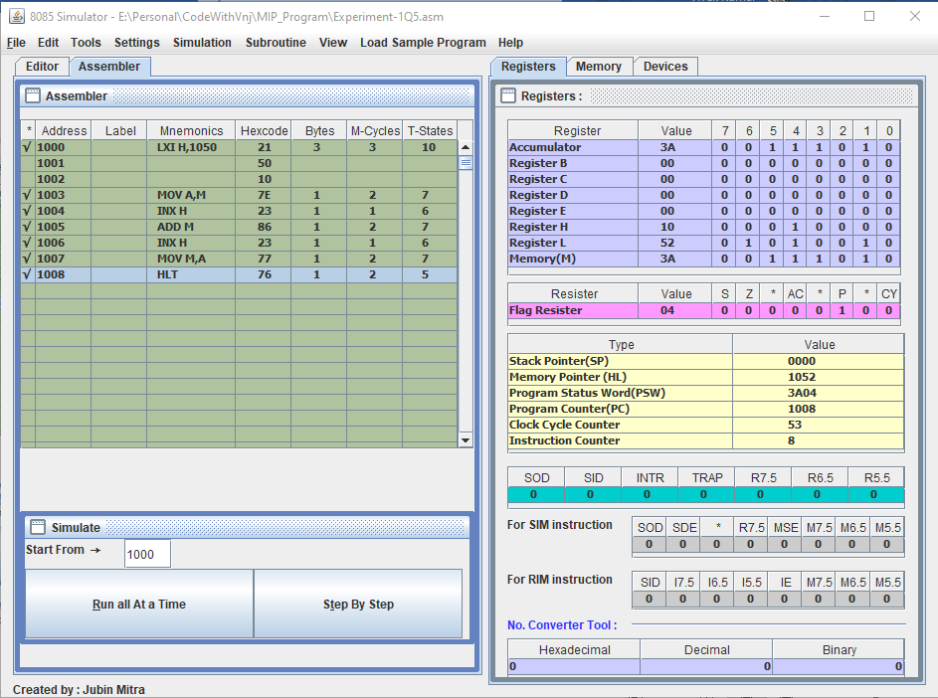

**Learning outcomes (What I have learnt):**

**1.** Learnt how to do the 8085-microprocessor programming.

**2.** Learnt how to add the two 8bit numbers with the carry.

**3.** Learnt how to add the two 8bits numbers without the carry.

**Evaluation Grid (To be created as per the SOP and Assessment guidelines by the faculty):**

|  |  |  |  |
| --- | --- | --- | --- |
| Sr. No. | Parameters | Marks Obtained | Maximum Marks |
| 1. |  |  |  |
| 2. |  |  |  |
| 3. |  |  |  |
|  |  |  |  |